- Data:

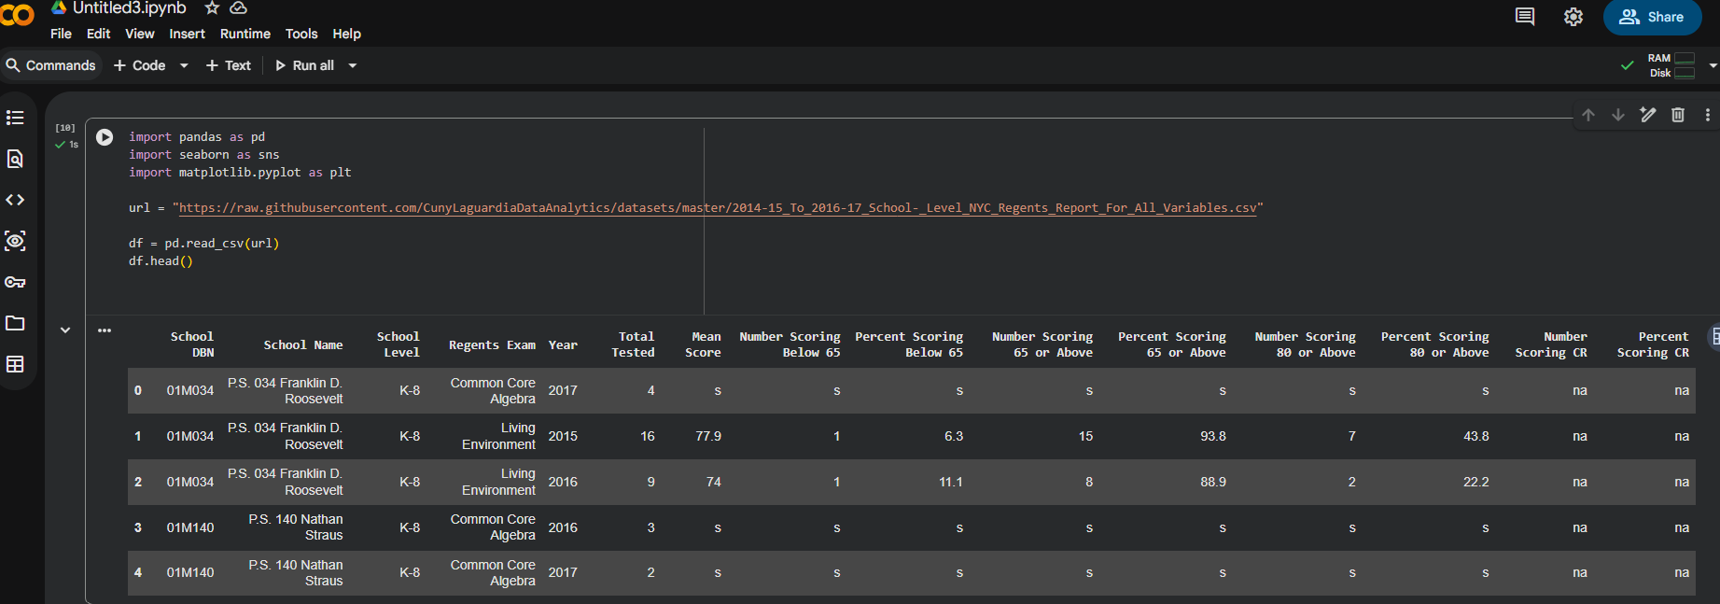
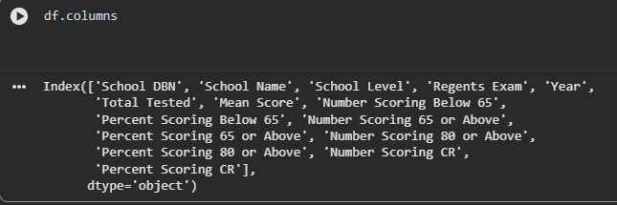
- Pick any school in this dataset as an initial comparison point.
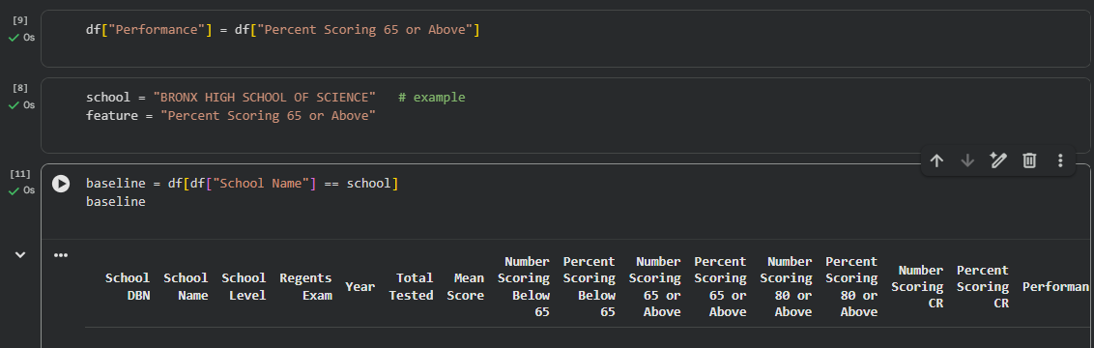

- Compare the above school to schools in the entire dataset, schools in a particular borough, or schools in a particular district.

- Comparison to all schools in the dataset
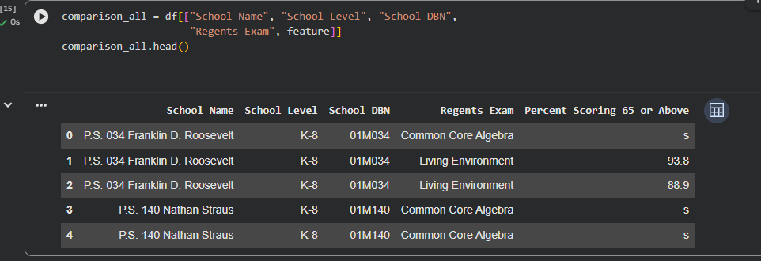
- Some descriptive statistics.
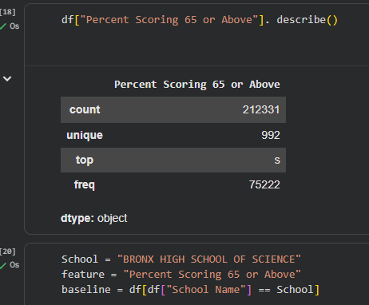
- Include one cleaning task (or more)
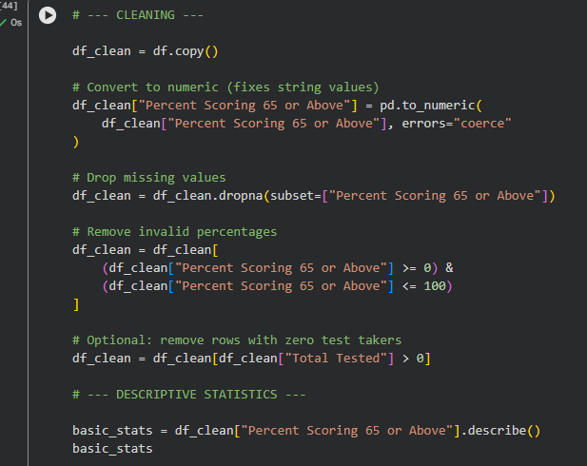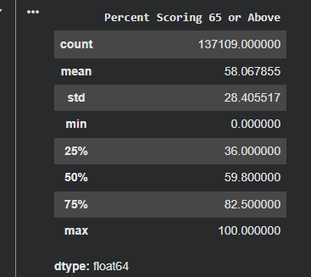

- Distribution of Regents Pass Rates (65%+)
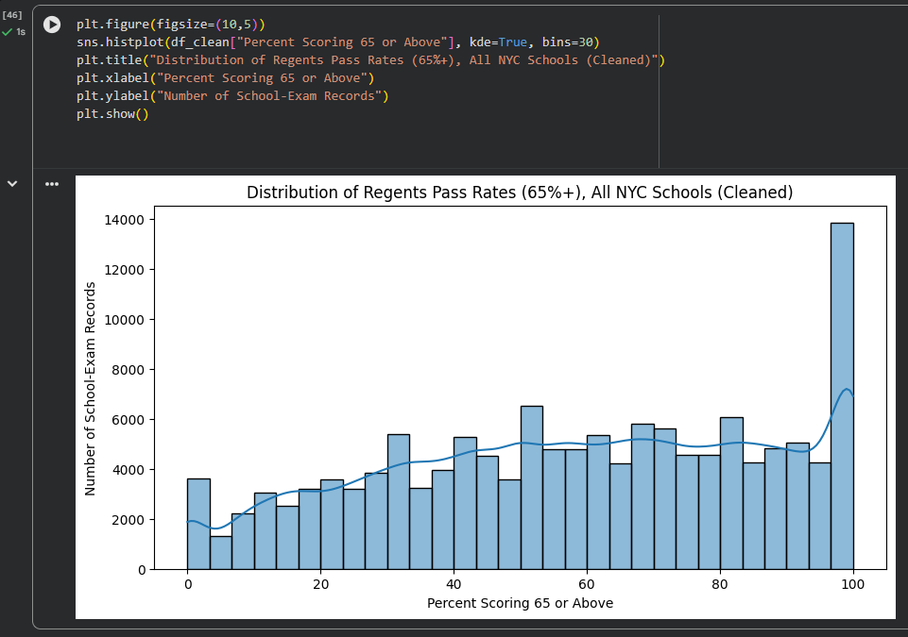
- Brief conclusion statement Conclusion
The cleaned dataset shows a wide range of Regents pass rates across NYC schools, with most schools clustering in the mid‑performance range and a smaller number achieving very high or very low results. The distribution suggests meaningful variation in outcomes, making this feature a strong basis for comparing individual schools to citywide performance.

